Multi-App Integration: Telegram + Airtable Logger
Dina Bosma-Buczynska
Note: This lab was completed using Telegram (instead of Discord) and Airtable (instead of Google Sheets) as instructor-approved alternatives. All functionality and success criteria remain the same.

Use Case and Backstory
As an AI consultant, client questions and requests arrive through messaging platforms on a daily basis. Manually copying these messages into a tracking spreadsheet is time-consuming and error-prone. This lab automates that process by building a workflow in n8n that listens for incoming messages in real time and logs them automatically to a structured Airtable base.

The original lab specified Discord as the messaging source. Because the Discord Trigger node was not available in this version of n8n Cloud, Telegram was used as an instructor-approved alternative. Telegram provides a straightforward bot API that integrates directly with n8n's Telegram Trigger node, making it a reliable substitute for the same pattern.

The core workflow pattern remains identical: one external event (an incoming message) triggers automatic data transformation and logging across two connected systems.

Workflow Overview
The workflow connects three nodes in sequence:

Telegram Trigger (receives live messages from Telegram bot)
|
v
Edit Fields / Set Node (transforms Telegram data to Airtable format)
|
v
Airtable: Create a Record (appends new row to the tracker)

Unlike the initial version of this lab which used a Manual Trigger with test data, this final version uses a live Telegram Trigger. This means every real message sent to the Telegram bot is captured and logged automatically, without any manual execution needed.

Screenshot 1: Live Telegram Message
A real message was sent through Telegram to test the live trigger. The message 'What is the weather in Berlin' was sent at 14:15 and appears as row 20 in the Airtable tracker, confirming the end-to-end connection between Telegram and Airtable.


Figure 1: Live Telegram message 'What is the weather in Berlin' sent at 14:15, logged as row 20 in Airtable

Screenshot 2: n8n Workflow with Telegram Trigger
The workflow shows all three active nodes connected in sequence, all showing green checkmarks confirming successful execution. The trigger is now a Telegram Trigger node (Updates: message), replacing the Manual Trigger used in the initial test phase.

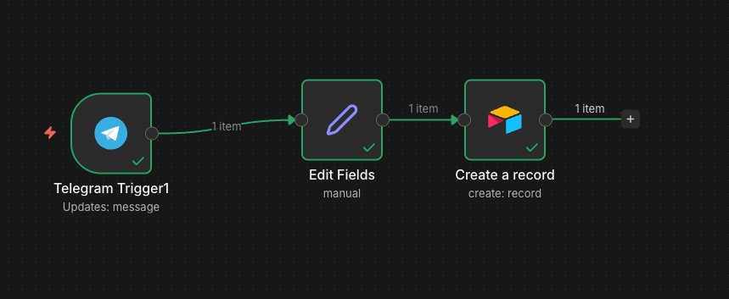
Figure 2: n8n workflow with Telegram Trigger -> Edit Fields -> Airtable Create Record, all nodes executed successfully

Screenshot 3: Airtable Tracker with Live Entries
The Airtable tracker shows six logged entries. Rows 15 to 17 are from the initial Manual Trigger test phase. Row 18 is a subsequent manual test. Row 19 was logged with an empty Question field (a missed capture before the workflow was fully active). Row 20 contains the live Telegram message 'What is the weather in Berlin', confirming the live trigger is working correctly.

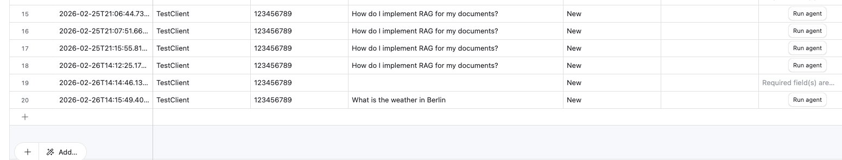
Figure 3: Airtable tracker showing rows 15 to 20, with row 20 capturing the live Telegram message

Success Criteria Check

Criteria | Status
Successfully created n8n workflow | Done
Telegram messages logged to tracker (live trigger) | Done
Data is correctly formatted | Done
All columns are populated correctly | Done
Workflow executes without errors | Done

How the Data Was Transformed
The Edit Fields (Set) node translates the incoming Telegram message format into the column structure expected by Airtable. The field mappings are:

Timestamp = {{ $now.toISO() }}
Client Name = {{ $json.message.from.username }}
Channel = {{ $json.message.chat.id }}
Question = {{ $json.message.text }}
Status = New

Telegram structures its data differently from Discord. Instead of top-level fields like 'username' and 'content', Telegram nests data inside a 'message' object. This means the expressions use paths like $json.message.text instead of $json.content. The Set node handles this mapping transparently so Airtable always receives clean, consistently formatted data.

The Timestamp uses .toISO() to convert n8n's DateTime object into an ISO 8601 string (e.g., 2026-02-26T14:15:49.40Z), which is the format Airtable requires for its Date/Time field type.

Challenges Encountered
- Discord Trigger not available: The Discord Trigger node is not available in this version of n8n Cloud. Following instructor guidance, Telegram was used as a replacement. A Telegram bot was created via BotFather, and the Telegram Trigger node was configured in n8n to listen for incoming messages.
- Airtable API token permissions: The token initially lacked the schema.bases:read scope, preventing n8n from loading column names. Fixed by adding the scope in Airtable's token settings and refreshing the connection.
- Incorrect Base ID format: Pasting the full Airtable URL into the Base field caused a 404 error. Fixed by switching to 'By ID' mode and entering only the app... and tbl... identifiers.
- Timestamp format mismatch: Airtable rejected the raw $now value. Fixed by changing the expression to $now.toISO().
- Row 19 logged with empty Question field: One message was captured before the Telegram field mappings were fully saved, resulting in a row with a missing Question. All subsequent messages logged correctly.

Troubleshooting Log

Error | Cause | Fix
NOT_FOUND (404) on Airtable node | Full Airtable URL used instead of Base ID | Switched to 'By ID' mode, used only the app... and tbl... IDs from the URL
No columns found in Airtable | API token missing schema.bases:read scope | Added the scope in Airtable token settings, clicked Retry in n8n
Request invalid or could not be processed | Timestamp not in ISO 8601 format required by Airtable | Changed {{ $now }} to {{ $now.toISO() }} in Set node
Records created with empty fields | Manual mapping mode with no fields configured | Switched Airtable node to Map Automatically mode
Row 19 logged with empty Question field | Telegram message sent before workflow was active (missed capture) | Confirmed workflow was active; subsequent messages logged correctly
Discord Trigger not available | Node not available in this version of n8n Cloud | Replaced with Telegram Trigger (instructor-approved alternative)

How This Workflow Could Be Extended
- Add a filter node to only log messages containing specific keywords like 'help', 'question', or 'issue', reducing noise in the tracker.
- Use an AI node to auto-categorize incoming questions by type: technical, billing, or general, and write the category to a new Airtable column.
- Add a Telegram response node to automatically reply to the user confirming their question was logged.
- Add deduplication logic to check whether identical message content already exists in Airtable before appending.
- Extend to multiple Telegram bots or channels, each logging to a different sheet or filtered view in Airtable.
- Add a 'Responded' status update triggered when the consultant sends a reply, closing the loop automatically.

Comprehensive Summary

What We Built
A live multi-app integration workflow in n8n that captures real Telegram messages and automatically logs them to a structured Airtable tracker. The workflow runs without any manual intervention: every message sent to the Telegram bot is transformed and appended to the tracker in real time.

Step-by-Step Recap
- Created the Airtable base: 'Client question tracker' with columns: Timestamp, Client Name, Channel, Question, Status, and Follow-up Date.
- Built the n8n workflow: Named 'Discord to Google Sheets Logger', initially with Manual Trigger, Edit Fields, and Airtable Create Record nodes.
- Debugged Airtable connection: Resolved four configuration errors: API token scope, Base ID format, Timestamp format, and mapping mode.
- Replaced Manual Trigger with Telegram Trigger: Created a Telegram bot via BotFather, connected it to n8n using the Telegram Trigger node (Updates: message).
- Updated field mappings: Adjusted Set node expressions to match Telegram's nested data structure ($json.message.text, $json.message.from.username, $json.message.chat.id).
- Tested with a live message: Sent 'What is the weather in Berlin' via Telegram at 14:15. The message appeared as row 20 in Airtable, confirming full end-to-end functionality.

Key Concepts Learned
- Live triggers vs manual triggers: A Telegram Trigger listens continuously for new messages without any manual execution. This is the production-ready version of what a Manual Trigger simulates during testing.
- Nested JSON paths: Different messaging platforms structure their data differently. Telegram nests data inside a 'message' object, requiring paths like $json.message.text. Always inspect the actual data structure in the node output before writing expressions.
- The Set node as a translation layer: Keeping all field mapping logic in one dedicated Set node makes it easy to adapt the workflow to any source platform. Only the Set node needs to change if the source switches from Telegram to Slack, WhatsApp, or another tool.
- {{ $now.toISO() }} for date fields: Destination systems like Airtable require dates in a specific string format. Always check what format the target field expects and apply the appropriate conversion expression.
- Map Automatically mode: When Set node output field names match Airtable column names exactly, Map Automatically eliminates the need for manual field-by-field configuration in the Airtable node.
- Testing before going live: Starting with a Manual Trigger allowed the Airtable connection and field mappings to be validated before connecting the live Telegram trigger. This prevents bad data from entering the tracker during setup.

